Evolution

Communications Design Concept Document

By: Tom Fink/Steve Manger



Hobart Corporation
Troy, Ohio

Revision History
Date | Change Description
4/24/02 | Initial Approval (Harry Collins, Dave Miller)
9/3/04 | Updated to show changes made during implementation of design

1 Communications Architecture Overview

2 Introduction
- The Evolution replaces the Ultima/Quantum Module Network (Low Speed and High Speed) with a USB network. This document describes the Communications code that controls that network.
- This design has two main goals:
    - To reuse the Ultima/Quantum code, architecture, and data structures as much as possible.
    - To simplify the Ultima/Quantum code and architecture by taking advantage of USB's built in features.

3 Virtual "High Speed" and "Low Speed" networks.
- The USB architecture establishes "Pipes" between physical devices. These pipes share one physical network, but from a logical view, they form a direct, unidirectional link between software devices (for example, between the weigher peripheral and the weigher manager on the system controller).
- Two Pipes, one IN and one OUT (In USB parlance, IN and OUT are referenced from the Host's point of view. In the Evolution, the System Controller is the Host) replace the "Low Speed Module Network's" functionality. These pipes are configured as "Interrupt Pipes" (An Interrupt Pipe is one of the four types of pipes defined in the USB spec), which are well suited for short, time critical messages.
- Another IN and OUT pipe replace the High Speed Network's functionality. These Pipes are intended to move large blocks of data, similar to the Ultima/Quantum High Speed Network. They are configured as "Bulk Pipes" (A Bulk Pipe is one of the four types of pipes defined in the USB spec). In addition, the peripheral hardware can be configured to load/unload the Bulk Pipes via a DMA controller. This makes them even more suited to moving large blocks of data (such as a print image).

4 Multiple Software "Devices" per Peripheral
- Although each Evolution Peripheral has dedicated pipes to the system controller, the Peripherals can have multiple internal software Devices. A simple example of this is the Printer, which has Printer, System, and USBCommunication Devices. A more complex example would be a front room unit which might have Printer, Customer Display, Weigher, System, and USBCommunication Devices in one physical peripheral
- The Evolution's USB Endpoint controller only has 3 IN, 3 OUT, and 1 CONTROL pipes. Therefore it's not possible to dedicate one pipe to each software device (without reconfiguring the endpoint controller)

5. Communications Diagrams
- The following Diagram shows the "Electrical" view of the USB network.
  - The USB Network is physically configured as a "tree", with the host being the trunk of the tree.
  - Unlike the LSMN which is multi-drop, the USB network is master-slave. All communications are controlled by the host. There are no packet collisions.
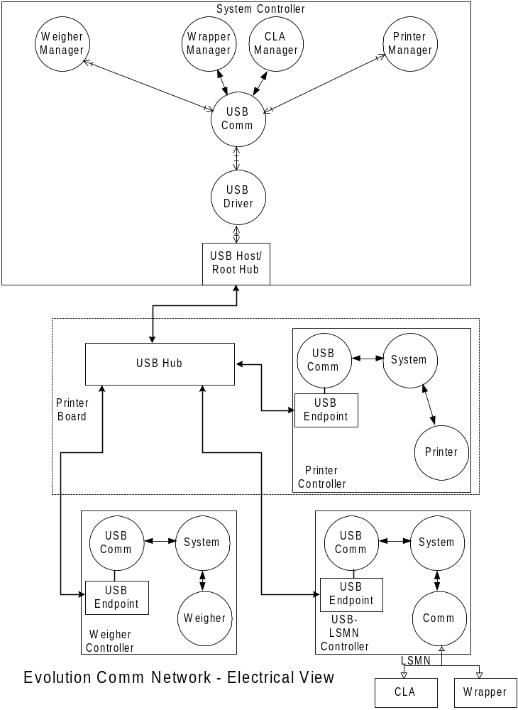

- The following diagram shows the "Logical" view of the USB network.
  - In this view, every USB Peripheral has a direct Pipe(s) to/from the System Controller. Each Peripheral is unaware of all the other peripherals.
    - Note that a USB peripheral is defined by the "USB Endpoint" hardware in electrical view.
  - If a pipe to one of the peripherals is disabled, all other pipes are in no way affected. Normal operation continues. For instance, if the Weigher Controller OUT Pipe is shut down, the Weigher OUT pipe, and all Printer and USB/LSMN pipes are still operational.
  - If the Interrupt OUT pipe to the Printer Peripheral is disabled, all Software Devices (System, Sec Lab Applier, Printer) in the Printer Peripheral can't receive messages (on that pipe) from the System Controller until the Interrupt Out Pipe is re-enabled. However, disabling the Interrupt Pipe in no way affects the Bulk Pipe operation (other than not being able to set-up the next Bulk transfer).
  - Notice how the Wrapper and the CLA (on the LSMN) are aware of each other and have to worry about collisions. This is not the case for the peripherals on the USB network.
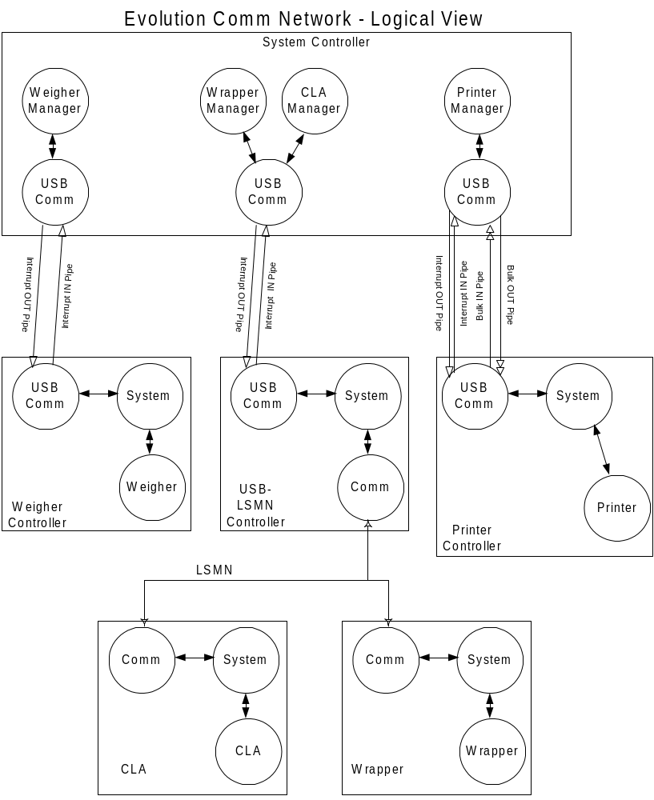

6 Data Structures

7.Comm Message

- The "Interrupt" Message Structure is similar to Ultima/Quantum Low Speed Messages. However, the Sequence Number and CRC fields have been eliminated because they're no longer needed.

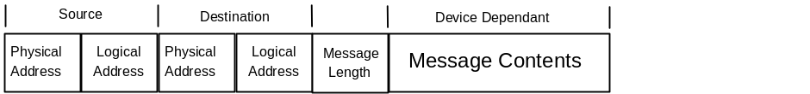

8 Physical and Logical Addresses

- The Physical Address is used on Evolution to distinguish between multiple, identical peripherals (i.e. multiple printers). No two peripherals can have the same Physical Address.

- The Evolution does not have a BROADCAST address like the Ultima/Quantum. Broadcast messages are sent separately to each device on the network.

- The Logical Address is used to name the Software/Hardware Module at a Physical Address. The Logical Address can not be changed and is a CONSTANT used to define the device type and it's function. No two software modules of different type can use the same logical address, although more than one Software Module, of the exact same function, with the same Logical Address can exist at different Physical Addresses.

- The combination of a Physical and a Logical address defines a Unique address.

9Address Data Structure

typedef word NetworkAddress;
typedef word DeviceAddress;

struct physical_address
{
NetworkAddress address;
word pad0;
};
typedef struct physical_address PhysicalAddress;

struct logical_address
{
word pad0;
DeviceAddress address;
};
typedef struct logical_address LogicalAddress;

struct unique_address
{
ulong address;
};
typedef struct unique_address UniqueAddress;

union system_address
{
PhysicalAddress physical;
LogicalAddress logical;
UniqueAddress unique;
};
typedef union system_address SystemAddress;

10 Message Queue/Comm Header
- A linked list of Comm Headers will form the Message Queue. The messages in the Message Queue are transmitted in a First In, First Out basis. Messages are not prioritized in any other way.

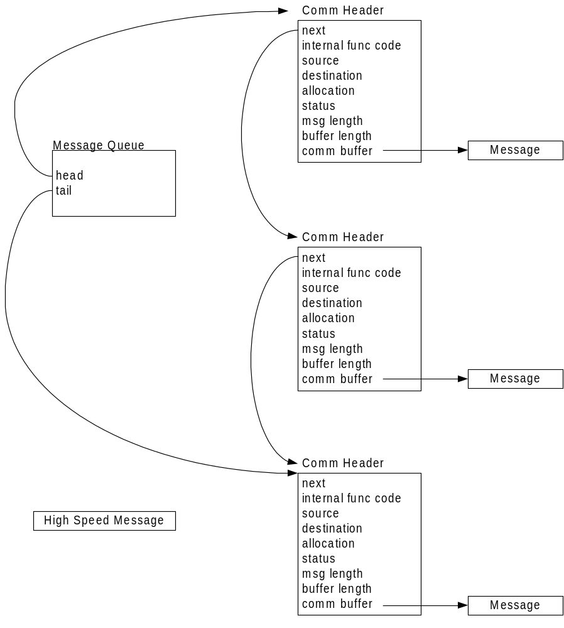

11 Comm Header

The "CommHeader" will provide the communications with vital information about each system message. In addition, it will provide a means by which messages can be grouped into ordered lists or queues by supplying a next pointer to another CommHeader.

struct comm_header
{
struct comm_header *next;
InternalFuncCode internal_func_code;
SystemAddress source;
SystemAddress destnation;
ubyte allocation : 1;
ubyte reserved : 7;
BufferStat status;
uint buffer_length;
ubyte *comm_buffer;
};
typedef struct comm_header CommHeader;

12 next
A pointer to the next "CommHeader" in a list.

13 internal_func_code
A function code used by the Communication Manager to determine the type of action to be taken on a message. These function codes consist of the following:

INTERRUPT PIPE TRANSMIT - Transmit this message on the Interrupt IN Pipe (peripheral) or the Interrupt OUT Pipe (System Controller).

INTERRUPT PIPE ALLOCATE - Allocate this message buffer to this device’s Interrupt Pipe receive buffers.

INTERRUPT PIPE RECEIVE - This message was received via the Interrupt Pipe.

BULK PIPE TRANSMIT - Transmit this message on the IN Bulk Pipe (Peripheral) or the OUT Bulk Pipe (System Controller).

BULK PIPE ALLOCATE - Allocate this message buffer to this device’s Bulk Pipe receive buffers.

BULK PIPE RECEIVE - This message was received via the Bulk Pipe.

14 source
See "System Address" definition

15 destination
See "System Address" definition

18 allocation
The allocation method used to create this message. This will either be STATIC_ALLOCATION or DYNAMIC_ALLOCATION.

19 status
The status of the message buffer. This will be one of the following:

BUSY
READY
FULL
EMPTY
FINISHED.

20 msg_length
The length in bytes of the message in the buffer

21 buffer_length
The length in bytes of the message buffer.

22 comm_buffer
A pointer to the message buffer.

23 Detailed Design

24 Interrupt Pipe Operation

- The Interrupt Pipes (one IN and one OUT pipe) replace the functionality of the Ultima/Quantum "Low Speed Network". That is, they are designed to transfer small, control oriented messages that are very time sensitive.
- A USB Interrupt Pipe guarantees a message can be sent to or received from a peripheral on a regular interval. This interval can be 1mS to 256mS, depending on the needs of the peripheral.
  - All USB transactions are initiated by the USB Host. For the IN Interrupt Pipe, the Host polls the peripheral at the specified interval to see if it has any messages to send.
- A restriction of an Interrupt Pipe is that only one message can be sent per interval. If the message is larger than the size of the Interrupt Endpoint (8, 16, 32, or 64 bytes), it takes two intervals to send the message. For this reason, Interrupt pipes are not suited for sending/receiving large amounts of data.
- The USB Hardware/Host Driver take care of the following:
  - CRC calculation and checking
  - retries due to busy devices or data reception errors,
  - packetizing & unpacketizing of messages larger than the endpoint buffer size.
- The Interrupt messages are actually sent in two Transfers. The first Transfer contains the Source and Destination Addresses. After receiving these, the Receive Manager knows which Software Device's Receive Buffer to put the Device Message in when it arrives in the next transaction.
- There will arise situations where either the peripheral or the system controller doesn't have the resources (Receive Buffers) to receive a message. The intention is allocate enough buffers so that these situations don't occur, but when they do, the following mechanism handles them:
  - If the System Controller doesn't have available receive buffers, it disables the Interrupt Pipe, preventing messages from arriving. It re-enables the pipe when receive buffers become available.
  - The following procedure is used when a Peripheral Device is out of Receive Buffers:
    - The Receive Manager determines if a Receive Buffer is available for the Destination Address it received in the first Transfer (Dest/Source part of the message). If there isn't, the Receive Manager doesn't re-enable the Interrupt Endpoint (the endpoints are disabled by hardware after receiving a data packet).
    - The Receive Manager then creates a Timer Event which will re-enable the pipe at a later time. This time should be as short as is reasonable (to allow the a buffer to become available). Five or ten milliseconds are examples of a reasonable time.
    - When the Timer Event expires, if a receive buffer is available, the Interrupt Pipe is re-enabled to receive the body of the message.
    - The System Controller Printer Manager keeps trying to resend the message for one second or more. If the message hasn’t been received when that time is up, a serious system error has occurred.

26.Bulk Pipe Operation

- The Bulk Pipes (one IN and one OUT) replace the functionality of the Ultima/Quantum "High Speed Network". That is, they are designed to move large amounts of data (such as a print image) with low software overhead.
  - USB Bulk pipes have no guaranteed bus bandwidth, but they can use all available bus bandwidth (unlike Interrupt Pipes that have a guaranteed, but very limited bandwidth).
- The Peripheral Hardware includes a DMA controller that is used to load/unload the Bulk Pipes with minimal software intervention. Because the DMA has to be initialized for each transfer it is necessary to set up the Bulk Transfers with a "Bulk Transfer Request" message on the Interrupt Pipe.
- The tasks that are "Automated", i.e. handled without software intervention, are listed below:
  - CRC calculation and checking
  - retries for busy devices and data reception errors,
  - packetizing & unpacketizing of messages larger than the endpoint buffer size.
  - Loading/Unloading the message data from/to RAM
- Because a DMA controller is used with the Bulk Pipes, a "Bulk Transfer Request" message is sent over the Interrupt Pipe prior to sending the data over the Bulk Pipe. The Bulk Data Transfer Request message tells the Receive Manager to configure the DMA for a Bulk Transfer and tells it which Receive Buffer to put the data in (if there's more than one software device receiving data over the Bulk Pipe).
- The Peripheral Receive Manager keeps track of how many Bulk Receive Buffers it has left. When it runs out of buffers, it sets the OUT_OF_BULK_DATA_BUFFERS bit in the Printer Status. A status message is then sent to the System Controller Printer Manager. The System Controller then stops sending data on the Bulk Pipe till it receives a status message with the OUT_OF_BULK_DATA_BUFFERS bit negated.
  - This revised scheme was implemented because VxWorks only has a crude “timeout” period to indicate the whole bulk message transfer wasn’t completed successfully. This period has to be set large enough to ENSURE the bulk message had enough time to transfer, but if it’s TOO big, the printer will run out of print data. Originally it was thought that the System Controller Print Manager would know the Bulk Pipe transfer was being NACKED within a few milliseconds.
  - If the System Controller tries a Bulk Transfer when no buffers are available the Periperal Receive Manager will ignore the Bulk Transfer Request message and will not initialize the hardware for a Bulk Pipe transfer.

- If the System Controller is out of Bulk Receive Buffers, the rolls are reversed. The Peripheral Controller times out if the Bulk Transfer hasn't started after a given period of time. It disables the Bulk Pipe and places the Bulk Message back on the Transmit Queue.

27The USB Communication Manager Message Flow

- The following diagram shows the flow of messages in the Comm Manager. The message flow is very much simplified from the Ultima/Quantum.
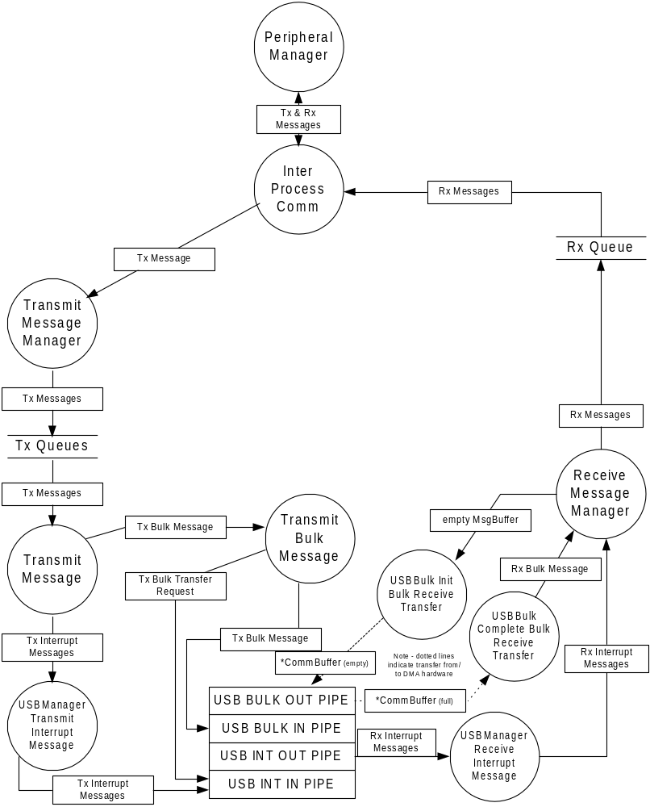

- "Transmit Message" pulls the messages off the Transmit Queue in a first in, first out manner and sends them to "Transmit Bulk Message" or "Transmit Interrupt Message", depending on the message type.
- "Transmit Bulk Message" generates the "Bulk Transfer Request" message that is sent over the Interrupt Pipe. At the same time it configures the DMA controller (Peripheral only) and enables the Bulk Endpoint for transmission of the Bulk Message. If the Bulk Message times out, the Message is placed back on the Transmit Queue for retransmission at a later time.
- If the "Receive Message Manager" receives a "Bulk Transmit Request", it enables the Bulk Pipe and (in a Periperal's case) configures the DMA controller for data reception. If a Bulk Receive Buffer is unavailable, the Bulk Pipe is left disabled and the "Bulk Transmit Request" message is discarded.

